Q1

SELECT \* FROM EMP WHERE

SAL IN (SELECT MAX(SAL) FROM EMP GROUP BY (DEPTNO)) OR SAL IN (SELECT MIN(SAL) FROM EMP GROUP BY (DEPTNO)) ORDER BY DEPTNO;

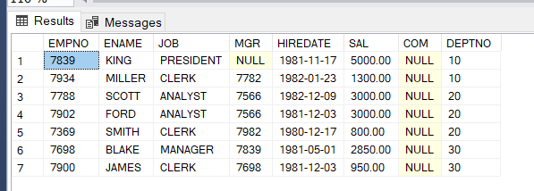

Q2

SELECT ENAME,EMPNO, DEPTNO FROM EMP

WHERE (DEPTNO > 20 AND DEPTNO IN (SELECT DEPTNO FROM DEPT WHERE DNAME LIKE '%A%'));

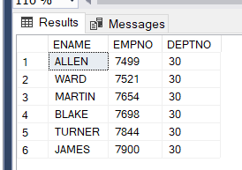

Q3

SELECT \* FROM EMP WHERE

(2\*SAL < (SELECT SAL FROM EMP WHERE JOB IN ('PRESIDENT')));

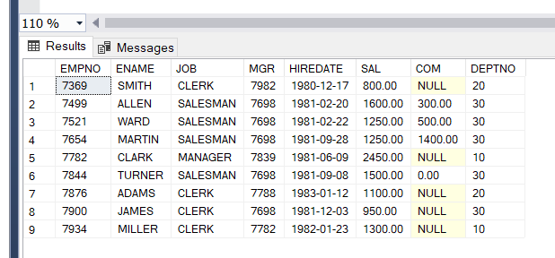

Q4

SELECT \* FROM EMP WHERE

(EMPNO NOT IN (SELECT MGR FROM EMP WHERE MGR IS NOT NULL)) 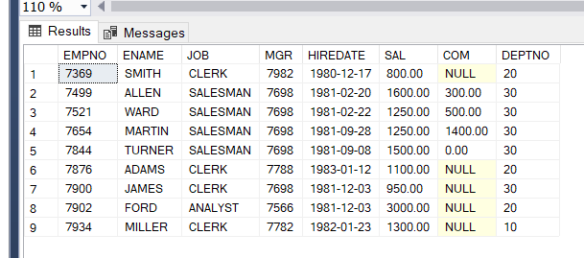

Q5

SELECT CONCAT(ENAME ,' is ',JOB) AS INTRO FROM EMP

